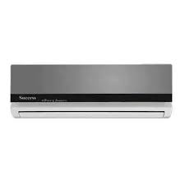

Success 18ADV

* Series Split AC
* Different Stylish Colors
* High-Quality Result
* Vary Depending Model
* Rs.44,000